# WEB0076 – Display Customer Agreement Number

|  |  |  |
| --- | --- | --- |
| **Requirement**  **Number** | **ID** | **Requirement Statement** |
| WEB0076 | 10916 | The solution shall default "Customer Agreement Number" to "ON". |

1. Open the ED Master-webr stored display
2. Expand the “Annotation” group layer

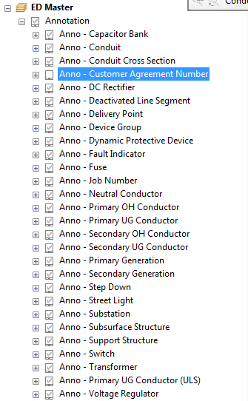

1. Click the “check box” option to on next to “Anno – Customer Agreement Number”

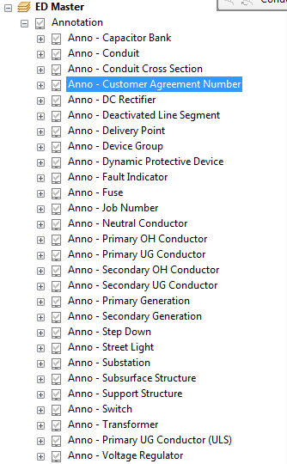

1. Minimize the “Annotation” group layer

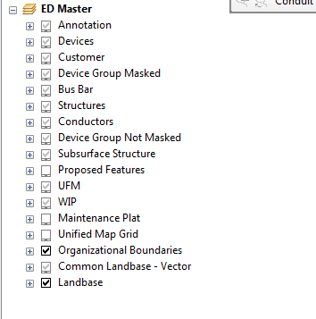

1. Save the MXD

# WEB0077 – Display Agreement Number

|  |  |  |
| --- | --- | --- |
| **Requirement**  **Number** | **ID** | **Requirement Statement** |
| WEB0077 | 10917 | The solution shall default "Agreement Number" to "ON". |

1. Open the ED Master-webr stored display
2. expand the “Customer” group layer

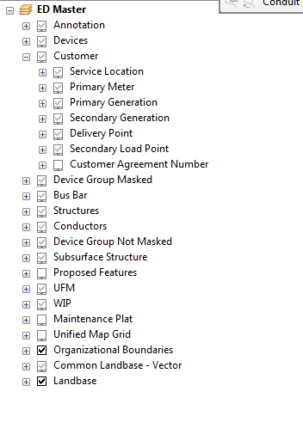

1. Click the “check box” option to on next to “Customer Agreement Number”

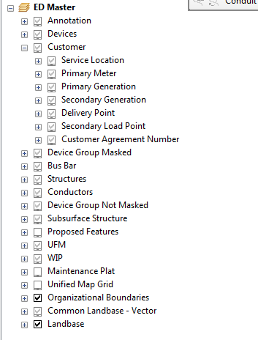

1. Minimize the “Customer” group layer



1. Save the MXD

# Joint Pole Display

|  |  |  |
| --- | --- | --- |
| **Requirement**  **Number** | **ID** | **Requirement Statement** |
| WEB0078 | 10918 | The solution shall display "JUA Label" as "Joint Pole #" and Default to “ON”. |

1. Open the ED Master-webr stored display
2. Expand the “Structures” group layer

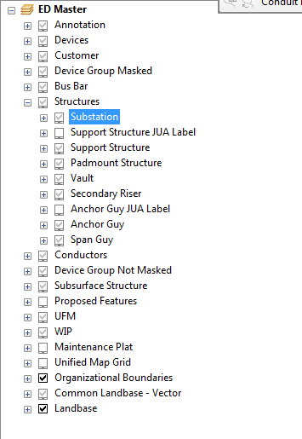

1. Click the “check box” option to on next to “Support Structure JUA Label” and “Anchor Guy JUA Label”

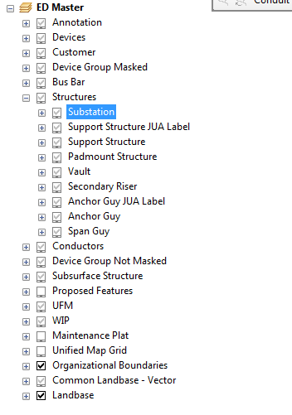

1. Minimize the “Structures” group layer

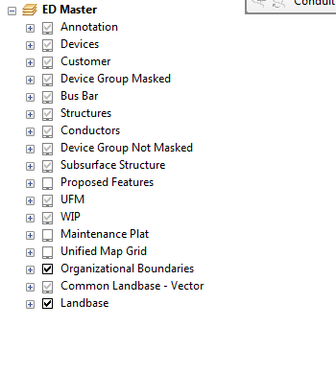

1. Save the MXD

# Update MXD Version control and Track changes

1. Right click on “ED Master” group layer and click properites

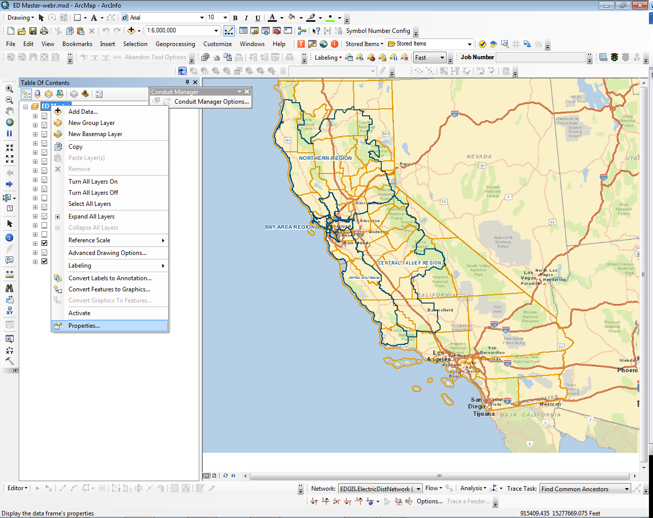

1. Click on the “General” tab and change the ‘Version’ accordingly, version numbers are not under the IBM development team’s control. Please verify the next version.

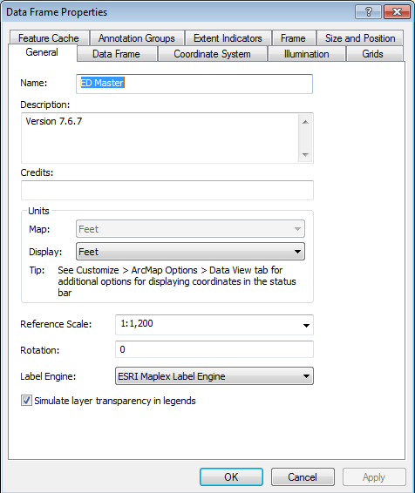

1. After updating the version, click OK to save and exit the properties and save the MXD

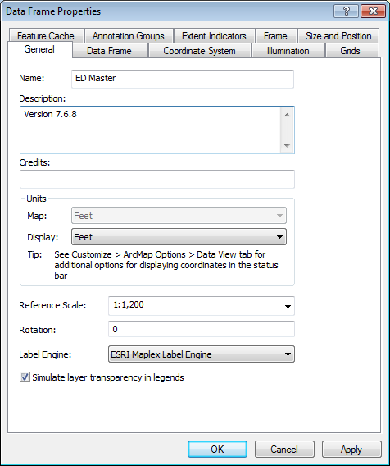

1. Open “Stored Display Component Spec&Change Log.xlsx” and update accordingly. version numbers are not under the IBM development team’s control. Please verify the next version.



1. Save Change log